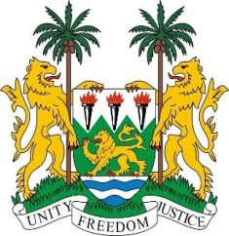

**SIERRA LEONE**

**46th Session of the UPR**

**REVIEW OF VANUATU**

Thursday, 2nd May 2024

**Check against delivery.**

Sierra Leone welcomes and thanks **Hon. John Amos Vacher, Minister of Justice and Community Services,** and the distinguished delegation from Vanuatu for the presentation of its national report.

Sierra Leone commends Vanuatu for several human rights-based policies and measures aimed at advancing the Sustainable Development Goals. We welcome the establishment of the National Gender Policy, accompanied by its six provincial plans, which provide strategic directions for achieving gender equality.

As a disaster-prone country, we commend the Government for its measures to address climate change, including the establishment of the National Disaster Management Office and the National Disaster Committee.

We also welcome the landmark Supreme Court ruling in the case of Prosecutor vs. Somon (2021), which upheld the prohibition of forced labour, human trafficking, and other forms of slavery.

While recognising that Vanuatu has no provision for the death penalty in law or practice, we recommend that it:

1.    Ratify the Second Optional Protocol to the International Covenant on Civil and Political Rights (ICCPR) to abolish the death penalty.

2.    Consider establishing an independent police mechanism, free from police control, to investigate police misconduct and brutality against civilians.

3.    Take concrete steps to address gender-based violence, including enacting legislation and implementing measures to protect victims and prosecute perpetrators.

Sierra Leone wishes Vanuatu every success in completing its fourth review cycle.

**Thank you, Mr. President.**